Crownfield Eye Hospital
Part C- individual SQL and Validation
Individual SQL implementation, execution and validation

- Introduction
Part C requires the independent creation, execution and explanation of six purposeful SQL queries for the Crownfield Eye Hospital ophthalmology database. The six queries demonstrate an aggregate query using GROUP BY and HAVING, an INNER JOIN across at least three related tables, a LEFT JOIN that reveals missing related data, a subquery, a stored procedure with an input parameter, and a trigger that enforces a meaningful business rule.
Each query explains what information it is used to find, shows the SQL code, includes the expected test results and describes how the results show that the query is working correctly.
- Query 1 – GROUP BY and HAVING
Business question
Which clinicians have been assigned at least two appointments?
SQL implementation
c.clinician_id,
CONCAT (c.first_name, ' ', c.last_name) AS clinician_name,
COUNT(a.appointment_id) AS total_appointments
FROM clinician c
INNER JOIN appointment a
ON c.clinician_id = a.clinician_id
GROUP BY
c.clinician_id,
c.first_name,
c.last_name
HAVING COUNT(a.appointment_id) >= 2
ORDER BY total_appointments DESC;
Validation and expected result
The query groups appointment records by clinician and counts the appointments assigned to each clinician. HAVING then filters the grouped results so that only clinicians with two or more appointments are returned. The result is therefore evidence that the aggregate calculation and filter are working together correctly.
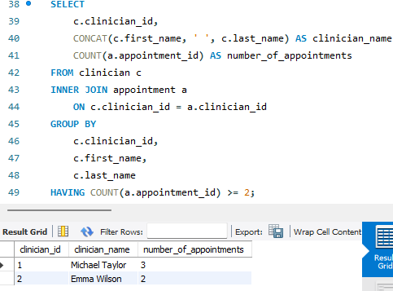
Figure 1 MY SQL WORKBENCH RESULT FOR QUERY 1 SCREENSHOT

- Query 2 – INNER JOIN Across Four Tables
Business question
Which patients have appointments, and which clinicians are responsible for them?
SQL implementation
SELECT
a.appointment_id,
CONCAT (p.first_name, ' ', p.last_name) AS patient_name,
CONCAT (c.first_name, ' ', c.last_name) AS clinician_name,
cl.clinic_name,
a.appointment_date,
a.appointment_time,
a.status
FROM appointment a
INNER JOIN patient p
ON a.patient_id = p.patient_id
INNER JOIN clinician c
ON a.clinician_id = c.clinician_id
INNER JOIN clinic cl
ON a.clinic_id = cl.clinic_id
ORDER BY
a.appointment_date,
a.appointment_time;
Validation and expected result
This query uses INNER JOIN to combine appointment, patient, clinician and clinic records. Foreign-key relationships connect each appointment to the corresponding patient, clinician and clinic. Because INNER JOIN returns matching related records, the result should provide a complete appointment schedule containing the requested details. The screenshot should show these combined columns and confirm that the joins execute successfully.

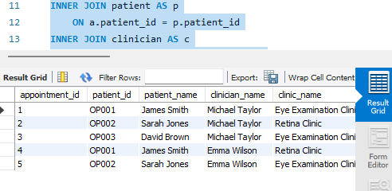
Figure 2 MY SQL WORCKBENCH FOR QUERY 2 SCREENSHOT

- Query 3 – LEFT JOIN
Business question
Which appointments do not currently have a recorder diagnosis?
SQL implementation
SELECT
a.appointment_id,
CONCAT(p.first_name, ' ', p.last_name) AS patient_name,
a.appointment_date,
a.appointment_time,
a.status
FROM appointment a
INNER JOIN patient p
ON a.patient_id = p.patient_id
LEFT JOIN diagnosis d
ON a.appointment_id = d.appointment_id
WHERE d.diagnosis_id IS NULL
ORDER BY a.appointment_date;
Validation and expected result
Even though sometimes no corresponding diagnosis exists the LEFT JOIN keeps the appointment records. The condition d.diagnosis_id IS NULL then selects appointments where the optional diagnosis record is missing. Therefore, the returned rows demonstrate the intended behaviour: appointments are identified specifically because they have no recorded diagnosis.

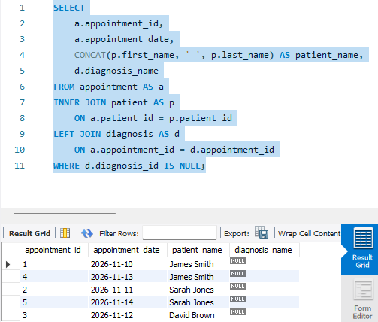
Figure 3 MY SQL WORKBENCH RESULT FOR QUERY 3 SCREENSHOT

- Query 4 – Subquery
Business question
Which clinicians have more appointment than the average clinician?
SQL implementation
SELECT
a.appointment_id,
CONCAT (p.first_name, ' ', p.last_name) AS patient_name,
a.appointment_date,
a.appointment_time,
a.status
FROM appointment a
INNER JOIN patient p
ON a.patient_id = p.patient_id
LEFT JOIN diagnosis d
ON a.appointment_id = d.appointment_id
WHERE d.diagnosis_id IS NULL
ORDER BY a.appointment_date;

Validation and expected result
The LEFT JOIN keeps appointment records even when no corresponding diagnosis exists. The condition d.diagnosis_id IS NULL then selects appointments where the optional diagnosis record is missing. Therefore, the returned rows demonstrate the intended behaviour: appointments are identified specifically because they have no recorded diagnosis.

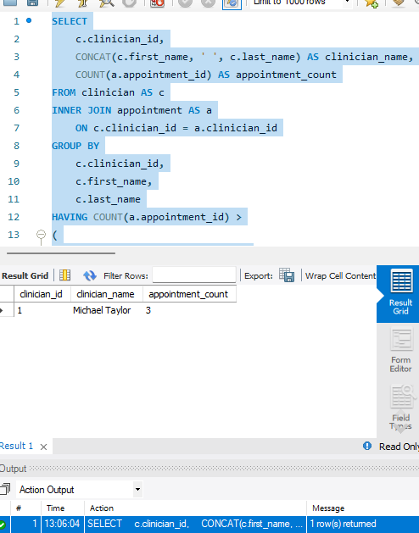
Figure 4 MY SQL WORKBENCH RESULT FOR QUERY 4 SCREENSHOT

- Query 5 – Stored Procedure with Input Parameter
Business question
How can hospital staff retrieve all appointments for a specific patient?

SQL implementation – create procedure

DROP PROCEDURE IF EXISTS get_patient_appointments;

DELIMITER $$

CREATE PROCEDURE get_patient_appointments(
IN p_patient_id VARCHAR(10)
)
BEGIN
SELECT
a.appointment_id,
a.patient_id,
a.appointment_date,
a.appointment_time,
CONCAT (c.first_name, ' ', c.last_name) AS clinician_name,
cl.clinic_name,
a.status
FROM appointment a
INNER JOIN clinician c
ON a.clinician_id = c.clinician_id
INNER JOIN clinic cl
ON a.clinic_id = cl.clinic_id
WHERE a.patient_id = p_patient_id
ORDER BY
a.appointment_date,
a.appointment_time;
END $$

DELIMITER;

Execution and validation
CALL get_patient_appointments('OP001');

CALL get_patient_appointments('OP002');
The stored procedure accepts a patient identifier through the input parameter p_patient_id. It then retrieves appointments matching that identifier and joins the clinician and clinic tables to provide useful appointment details. Testing the procedure with different patient identifiers demonstrates that the same reusable SQL logic can retrieve different patients' appointment records.
For validation, the first screenshot should show the procedure being created successfully and/or the result of CALL get_patient_appointments('OP001'). A second screenshot should show the result for OP002. The returned records should relate to the patient identifier supplied to the procedure.
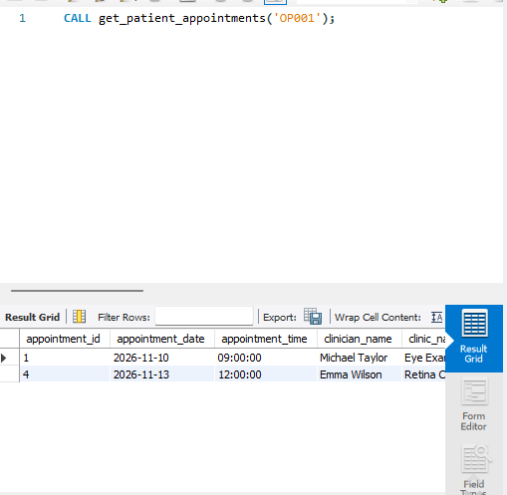
Figure 5 MY SQL WORKBENCH PROCEDURE CREATION/ EXCUTION FOR QUERY 5 SCREENSHOT

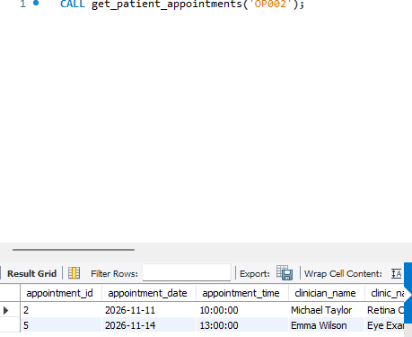
Figure 6 MY SQL WORKBENCH OP002 REST RESULT FOR QUERY 5 SCREENSHOT

- Query 6 – Trigger
Business question
How can the database prevent staff from recording a follow-up date earlier than the original appointment date?

SQL implementation – create trigger
DROP TRIGGER IF EXISTS trg_validate_followup_date;

DELIMITER $$

CREATE TRIGGER trg_validate_followup_date
BEFORE INSERT ON follow_up
FOR EACH ROW
BEGIN
DECLARE v_appointment_date DATE;

SELECT appointment_date
INTO v_appointment_date
FROM appointment
WHERE appointment_id = NEW.appointment_id;

IF NEW.due_date < v_appointment_date THEN
SIGNAL SQLSTATE '45000'
SET MESSAGE_TEXT =
'Follow-up date cannot be before appointment date';
END IF;
END $$
DELIMITER ;

Validation test
SHOW TRIGGERS
FROM crownfield_eye_hospital;
The trigger should appear as trg_validate_followup_date. To test the business rule, appointment 3 is scheduled for 16 November 2026. The following insert deliberately supplies an earlier follow-up date.
INSERT INTO follow_up
(
appointment_id,
due_date,
priority,
status
)
VALUES
(
3,
'2020-01-01',
'Routine',
'Pending'
);
Why the result demonstrates correct behaviour?
The insert is expected to fail because the supplied follow-up date is earlier than the appointment date. The trigger detects this condition before insertion and raises the message 'Follow-up date cannot be before appointment date'. This demonstrates automated enforcement of the hospital's business rule rather than relying on staff to identify the invalid date manually
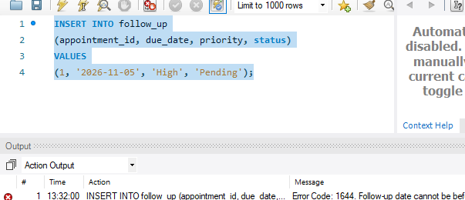
Figure 7 MY SQL WORKBENCH TRIGGER VALIDATION/EXPECTED ERROR FOR QUERY 6 SCREENSHOT

